MOSSMAN ELEMENTARY SCHOOL CARNIVAL
SATURDAY, FEBRUARY 24TH
10:30 AM – 3:30 PM

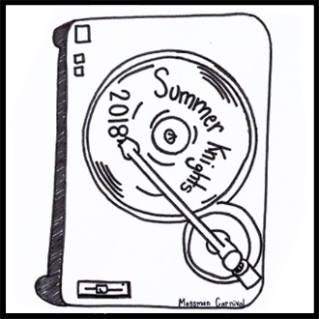

Student Volunteer Name: _________________________________________________________

Emergency Contact (Name and Number): ____________________________________________

Student Volunteer School: ________________________________________________________

Student Volunteer Email: _________________________________________________________

Name of club, organization or activity you represent: ___________________________________

Name of Mossman teacher that you are supporting: ___________________________________
(Our teachers can receive credit for your service too! If you know a Mossman teacher and would like to support them, please give us their name.)

Volunteers are needed from 10:30 am until 3:30 pm. Please indicate what shifts you will be able to work.

_____ 10:30 am – 12:00 pm

_____ 12:00 pm – 1:00 pm

_____ 1:00 pm – 2:00 pm

_____ 2:00 pm – 3:30 pm

****Upon arrival, please report to the Volunteer Desk at least 15 minutes prior to your shift to check in and please wear a shirt that supports your school or organization if possible****

If you have a friend that you would like to work with, please list them below (please only list one friend):
_____________________________________________________________________________________

When your shift is complete, return to the table to receive a statement regarding the amount of time you volunteered. We are extremely thankful for your help and if you have any questions please email me at carnivalvolunteers@mossmanpta.org. We had an absolutely fantastic group of volunteers last year and are looking forward to another great year!

VOLUNTEER FORMS ARE DUE BY TUESDAY, FEBRUARY 20, 2018

Thank you!!
Mossman Elementary PTA Carnival Volunteer Coordinators

